CMPE 314

Fall 2018

Transistor Characteristics

Joshua Bastian

Samuel Sogba

Riu Rjoopan

1. Purpose

In this lab we will be observing characteristics of a transistor. Observing voltage across the base-collector junction and base-emitter junction. The BJT will be in forward active mode and we will see how it is

1. Equipment



Resistors: 200K,2k

Transistor:2N3904 NPN

1. Procedure
2. Construct circuit in Figure 1, Rb is 200kohms and Rc is 2kohms.
3. Increase the DC Voltage Vbb from 0v to 3V with a step of 0.5V ,with each step increase Vcc from 0 to 10V

(calculate Ib and Ic)

1. Plot all the Ic vx Vce curves for a given Ib on the same plot
2. Vcc = 10V and vary Vbb 1V to 4V with a step of 0.5V. Measure Ic and Vce
3. Plot Ic vs Vce Also plot the theoretical Ic vs Vce loadline on the same plot
4. Use PScice to simulate steps 1 through 5 and compare results with your experimental results
5. 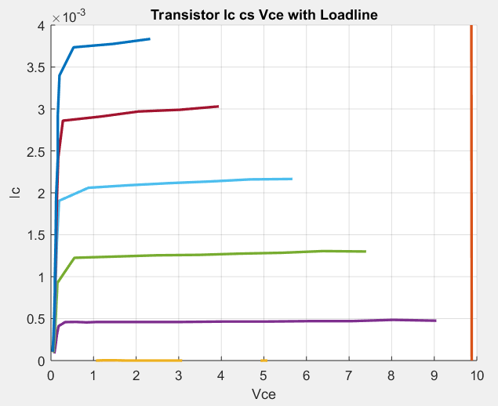Graphs

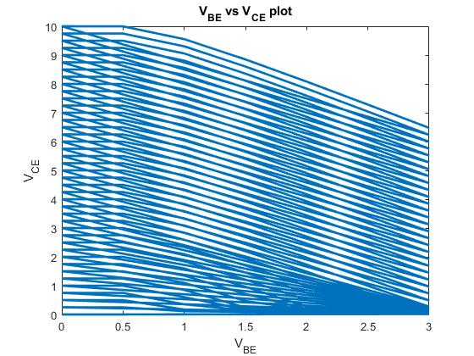

1. Calculations
$$I_{c }=(V_{cc }- V_{CE})/R_{c}$$

$$I_{B }=(V_{BB }- V_{BE})/R_{B}$$

2. Conclusion

In this lab we observed the transistor characteristics theoretical and experimental. The transistor is in forward active mode. In forward active mode the transistor acts as an amplification of current. The emitter to base acts forward biased and the collector to base acts forward biased. In our experiment we observed the amplification of current as the voltage across the Vce increased the current across the collector increased. This same relation was observed in our theoretical experiment. Problems we ran into our experimental portion of the lab was that the data we collected to develop our load line equation wasn’t accurate enough to the point it intersected with a current point, allowing us to observe the q point. BJT transistors in forward active mode main application is for current amplification we can use this property to strengthen weak input signals in sensor systems.